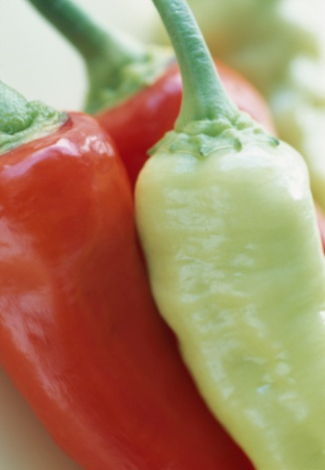
Salsa

1 – 28 oz. can of diced tomatoes
1 – 4 oz. can of diced green chiles
¼ cup thinly sliced green onion
¼ cup chopped fresh cilantro
2 Tablespoons lime juice
1/8 teaspoon pepper
1/2 teaspoon prepared garlic
¼ teaspoon salt or to taste

OPTIONAL INGREDIENTS:
1 Jalapeno Pepper
1 Serrano Pepper
Canned jalapenos
Hot sauce

Directions:
Drain tomatoes reserving only ¼ Cup of the juice
Combine the tomatoes and juice with the remaining ingredients.
Best after chilled.
Baked Tortilla Chips
Preheat the oven to 400º
Cut round tortillas into quarters or sixths.
Lay the chips in single layer on cookie sheets.
Spray the tops of the tortillas with non-stick spray.
Sprinkle with salt if desired.
Bake for 12-15 minutes total, turning the chips over at the 6 minute mark.

